**Mixed functions (Log, exponential, trigo)**P901  
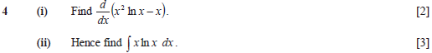  


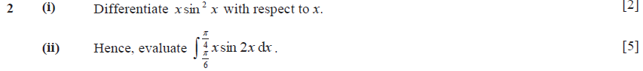  


  


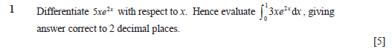

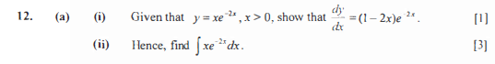  


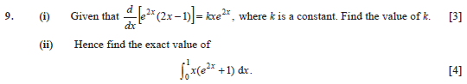  


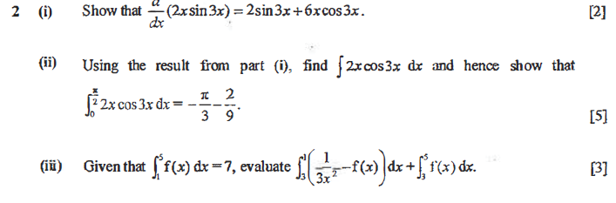  


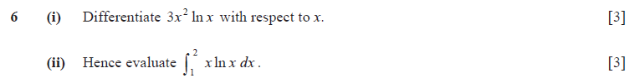



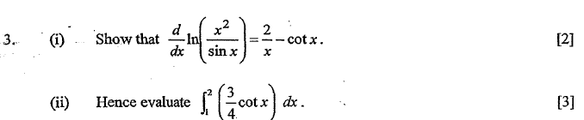

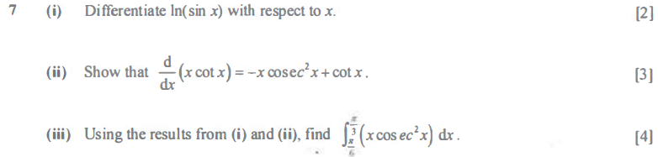

**Fractions**

p890  
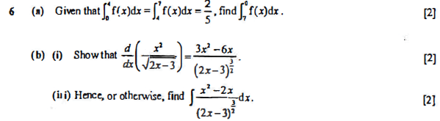  


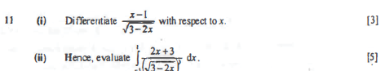



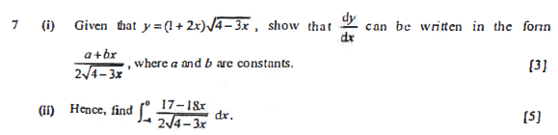



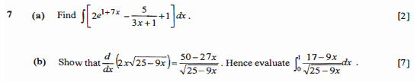

  

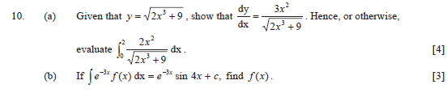



**Partial Fraction/ Integration**

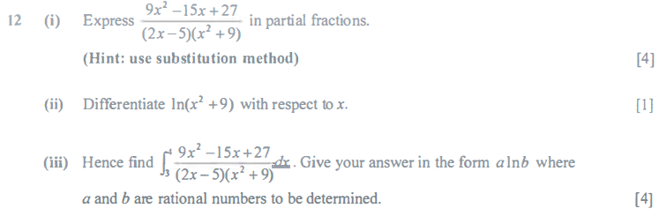



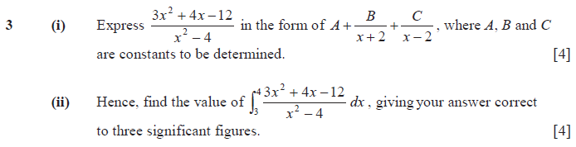  


**Integrals**

