Linear & repeated without long division







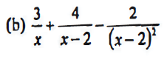

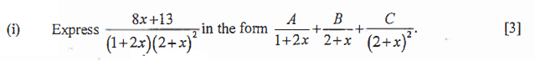  




  


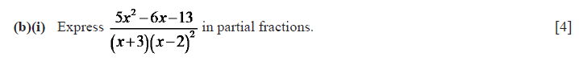



Linear & quadratic without long division





Linear with long division

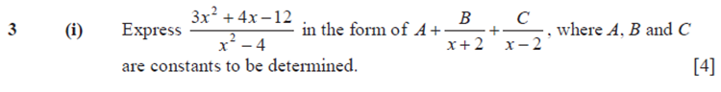  
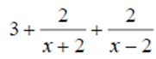

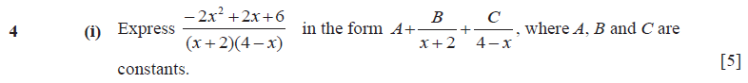  


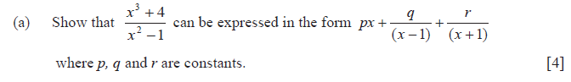  
  


Linear & quadratic with long division

