**Common question with 1 curve**  
  
Ans:

**Common questions with 1 curve 1 line**

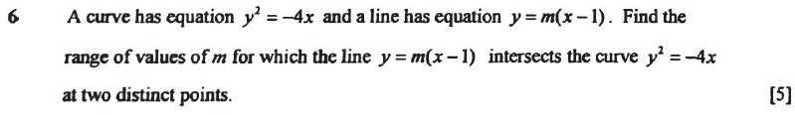  
Ans: 

  
Ans 

4)   
Ans: 

  
  
Ans: 

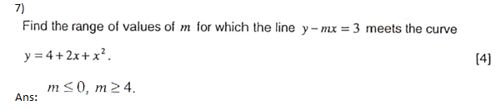

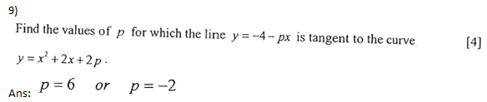

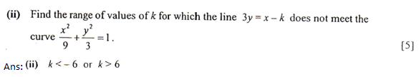

**Always positive or always negative questions**

  
Ans (The ans here is wrong. If curve needs to be always positive, then coefficient of x^2 must be +ve, so (p+6)>0, p>-6. So you can only accept p>2 as ans.

4   
  
Ans: 

  
Ans:  or 

4)  


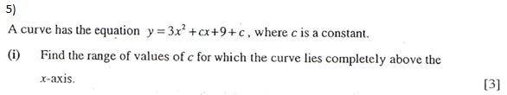  
Ans: 

6)  
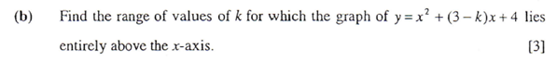  
Ans: -1 < k < 7

  


**Show questions (1 curve)**





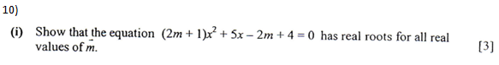

  
Ans: 

**Show questions (1 curve 1 line)**  
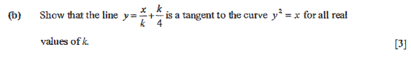

  


4  


