Given equation with roots α and β

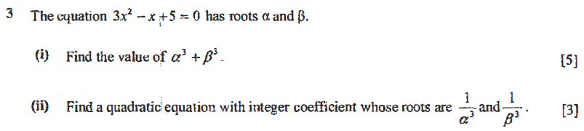  


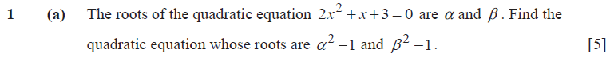  


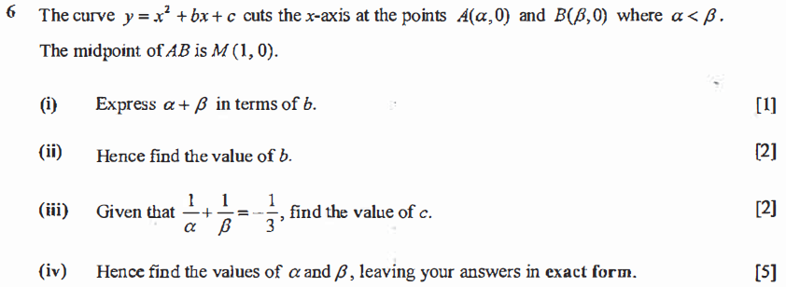  


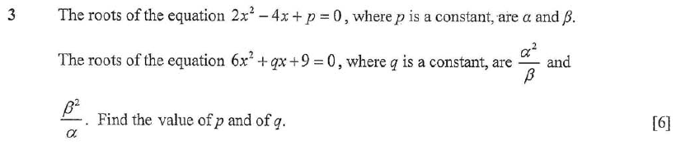  


Questions not starting with equation with roots α and β

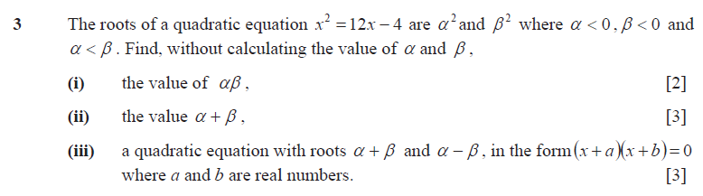  


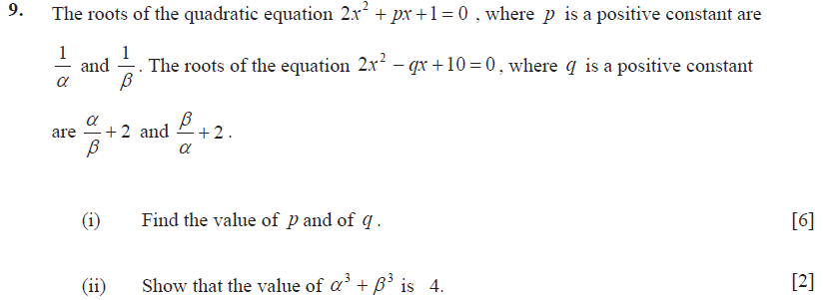  


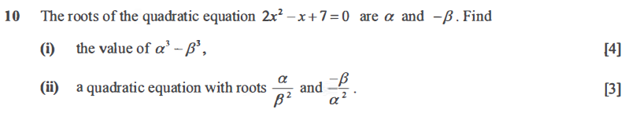  


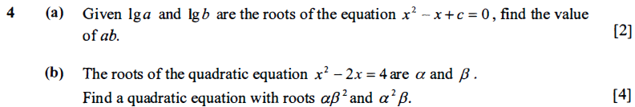  
  
Stopped at p290